# Usability tests

|  |  |  |  |  |
| --- | --- | --- | --- | --- |
| Test location | Usability tests | Expected result | Returned result | Evaluation |
| Data.html | If the user clicks the colour-blind button and its currently false in ColourBlindUser item | Changes the ColourBlindUser to true and edits the parts of the html that are not colour blind compliant | Changes the ColourBlindUser to true and edits the parts of the html that are not colour blind compliant | Correct |
|  | If the user clicks the colour-blind button and its currently true in ColourBlindUser item | Changes the ColourBlindUser to false and edits the parts of the html that are colour blind compliant | Changes the ColourBlindUser to false and edits the parts of the html that are colour blind compliant | Correct |
|  | If the user switch from a different page and was in colour blind mode | Stays in colour blind mode and ColourBlindUser is still true | Swaps to non-colour-blind mode but ColourBlindUser is still true | Incorrect  Should display the webpage in colour blind mode when changing pages |
| manualAdding  Information.html | If the user clicks the colour-blind button and its currently false in ColourBlindUser item | Changes the ColourBlindUser to true and edits the parts of the html that are not colour blind compliant | Changes the ColourBlindUser to true and edits the parts of the html that are not colour blind compliant | Correct |
|  | If the user clicks the colour-blind button and its currently true in ColourBlindUser item | Changes the ColourBlindUser to false and edits the parts of the html that are colour blind compliant | Changes the ColourBlindUser to false and edits the parts of the html that are colour blind compliant | Correct |
|  | If the user switch from a different page and was in colour blind mode | Stays in colour blind mode and ColourBlindUser is still true | Swaps to non-colour-blind mode but ColourBlindUser is still true | Incorrect  Should display the webpage in colourblind mode when changing pages |
| Patients-log.html | If the user clicks the colour-blind button and its currently false in ColourBlindUser item | Changes the ColourBlindUser to true and edits the parts of the html that are not colour blind compliant | Changes the ColourBlindUser to true and edits the parts of the html that are not colour blind compliant | Correct |
|  | If the user clicks the colour-blind button and its currently true in ColourBlindUser item | Changes the ColourBlindUser to false and edits the parts of the html that are colour blind compliant | Changes the ColourBlindUser to false and edits the parts of the html that are colour blind compliant | Correct |
|  | If the user switch from a different page and was in colour blind mode | Stays in colour blind mode and ColourBlindUser is still true | Swaps to non-colour-blind mode but ColourBlindUser is still true | Incorrect  Should display the webpage in colourblind mode when changing pages |
| patientsLog-temp.html | If the user clicks the colour-blind button and its currently false in ColourBlindUser item | Changes the ColourBlindUser to true and edits the parts of the html that are not colour blind compliant | Changes the ColourBlindUser to true and edits the parts of the html that are not colour blind compliant | Correct |
|  | If the user clicks the colour-blind button and its currently true in ColourBlindUser item | Changes the ColourBlindUser to false and edits the parts of the html that are colour blind compliant | Changes the ColourBlindUser to false and edits the parts of the html that are colour blind compliant | Correct |
|  | If the user switch from a different page and was in colour blind mode | Stays in colour blind mode and ColourBlindUser is still true | Swaps to non-colour-blind mode but ColourBlindUser is still true | Incorrect  Should display the webpage in colourblind mode when changing pages |
| Patients-sensor-readings.html | If the user clicks the colour-blind button and its currently false in ColourBlindUser item | Changes the ColourBlindUser to true and edits the parts of the html that are not colour blind compliant | Changes the ColourBlindUser to true and edits the parts of the html that are not colour blind compliant | Correct |
|  | If the user clicks the colour-blind button and its currently true in ColourBlindUser item | Changes the ColourBlindUser to false and edits the parts of the html that are colour blind compliant | Changes the ColourBlindUser to false and edits the parts of the html that are colour blind compliant | Correct |
|  | If the user switch from a different page and was in colour blind mode | Stays in colour blind mode and ColourBlindUser is still true | Swaps to non-colour-blind mode but ColourBlindUser is still true | Incorrect  Should display the webpage in colourblind mode when changing pages |
| profile.html | If the user clicks the colour-blind button and its currently false in ColourBlindUser item | Changes the ColourBlindUser to true and edits the parts of the html that are not colour blind compliant | Changes the ColourBlindUser to true and edits the parts of the html that are not colour blind compliant | Correct |
|  | If the user clicks the colour-blind button and its currently true in ColourBlindUser item | Changes the ColourBlindUser to false and edits the parts of the html that are colour blind compliant | Changes the ColourBlindUser to false and edits the parts of the html that are colour blind compliant | Correct |
|  | If the user switch from a different page and was in colour blind mode | Stays in colour blind mode and ColourBlindUser is still true | Swaps to non-colour-blind mode but ColourBlindUser is still true | Incorrect  Should display the webpage in colourblind mode when changing pages |
| stats.html | If the user clicks the colour-blind button and its currently false in ColourBlindUser item | Changes the ColourBlindUser to true and edits the parts of the html that are not colour blind compliant | Changes the ColourBlindUser to true and edits the parts of the html that are not colour blind compliant | Correct |
|  | If the user clicks the colour-blind button and its currently true in ColourBlindUser item | Changes the ColourBlindUser to false and edits the parts of the html that are colour blind compliant | Changes the ColourBlindUser to false and edits the parts of the html that are colour blind compliant | Correct |
|  | If the user switch from a different page and was in colour blind mode | Stays in colour blind mode and ColourBlindUser is still true | Swaps to non-colour-blind mode but ColourBlindUser is still true | Incorrect  Should display the webpage in colour blind mode when changing pages |

# Unit tests

|  |  |  |  |  |
| --- | --- | --- | --- | --- |
| Test location | Unit tests | Expected result | Returned result | Evaluation |
| Data.html | Never user website so ColourBlindUser item is added to local storage as a false | Adds ColourBlindUser to the local storage as a false | Adds ColourBlindUser to the local storage as a false | Correct |
|  | If the user clicks the colour-blind button and its currently false in ColourBlindUser item | Changes the ColourBlindUser to true and edits the parts of the html that are not colour blind compliant | Changes the ColourBlindUser to true and edits the parts of the html that are not colour blind compliant | Correct |
|  | If the user clicks the colour-blind button and its currently true in ColourBlindUser item | Changes the ColourBlindUser to false and edits the parts of the html that are colour blind compliant | Changes the ColourBlindUser to false and edits the parts of the html that are colour blind compliant | Correct |
|  | If the user switch from a different page and was in colour blind mode | Stays in colour blind mode and ColourBlindUser is still true | Swaps to non-colour-blind mode but ColourBlindUser is still true | Incorrect  Should display the webpage in colour blind mode when changing pages |
| manualAdding  Information.html | Never user website so ColourBlindUser item is added to local storage as a false | Adds ColourBlindUser to the local storage as a false | Adds ColourBlindUser to the local storage as a false | Correct |
|  | If the user clicks the colour-blind button and its currently false in ColourBlindUser item | Changes the ColourBlindUser to true and edits the parts of the html that are not colour blind compliant | Changes the ColourBlindUser to true and edits the parts of the html that are not colour blind compliant | Correct |
|  | If the user clicks the colour-blind button and its currently true in ColourBlindUser item | Changes the ColourBlindUser to false and edits the parts of the html that are colour blind compliant | Changes the ColourBlindUser to false and edits the parts of the html that are colour blind compliant | Correct |
|  | If the user switch from a different page and was in colour blind mode | Stays in colour blind mode and ColourBlindUser is still true | Swaps to non-colour-blind mode but ColourBlindUser is still true | Incorrect  Should display the webpage in colour blind mode when changing pages |
| Patients-log.html | Never user website so ColourBlindUser item is added to local storage as a false | Adds ColourBlindUser to the local storage as a false | Adds ColourBlindUser to the local storage as a false | Correct |
|  | If the user clicks the colour-blind button and its currently false in ColourBlindUser item | Changes the ColourBlindUser to true and edits the parts of the html that are not colour blind compliant | Changes the ColourBlindUser to true and edits the parts of the html that are not colour blind compliant | Correct |
|  | If the user clicks the colour-blind button and its currently true in ColourBlindUser item | Changes the ColourBlindUser to false and edits the parts of the html that are colour blind compliant | Changes the ColourBlindUser to false and edits the parts of the html that are colour blind compliant | Correct |
|  | If the user switch from a different page and was in colour blind mode | Stays in colour blind mode and ColourBlindUser is still true | Swaps to non-colour-blind mode but ColourBlindUser is still true | Incorrect  Should display the webpage in colour blind mode when changing pages |
| patientsLog-temp.html | Never user website so ColourBlindUser item is added to local storage as a false | Adds ColourBlindUser to the local storage as a false | Adds ColourBlindUser to the local storage as a false | Correct |
|  | If the user clicks the colour-blind button and its currently false in ColourBlindUser item | Changes the ColourBlindUser to true and edits the parts of the html that are not colour blind compliant | Changes the ColourBlindUser to true and edits the parts of the html that are not colour blind compliant | Correct |
|  | If the user clicks the colour-blind button and its currently true in ColourBlindUser item | Changes the ColourBlindUser to false and edits the parts of the html that are colour blind compliant | Changes the ColourBlindUser to false and edits the parts of the html that are colour blind compliant | Correct |
|  | If the user switch from a different page and was in colour blind mode | Stays in colour blind mode and ColourBlindUser is still true | Swaps to non-colour-blind mode but ColourBlindUser is still true | Incorrect  Should display the webpage in colour blind mode when changing pages |
| Patients-sensor-readings.html | Never user website so ColourBlindUser item is added to local storage as a false | Adds ColourBlindUser to the local storage as a false | Adds ColourBlindUser to the local storage as a false | Correct |
|  | If the user clicks the colour-blind button and its currently false in ColourBlindUser item | Changes the ColourBlindUser to true and edits the parts of the html that are not colour blind compliant | Changes the ColourBlindUser to true and edits the parts of the html that are not colour blind compliant | Correct |
|  | If the user clicks the colour-blind button and its currently true in ColourBlindUser item | Changes the ColourBlindUser to false and edits the parts of the html that are colour blind compliant | Changes the ColourBlindUser to false and edits the parts of the html that are colour blind compliant | Correct |
|  | If the user switch from a different page and was in colour blind mode | Stays in colour blind mode and ColourBlindUser is still true | Swaps to non-colour-blind mode but ColourBlindUser is still true | Incorrect  Should display the webpage in colour blind mode when changing pages |
| profile.html | Never user website so ColourBlindUser item is added to local storage as a false | Adds ColourBlindUser to the local storage as a false | Adds ColourBlindUser to the local storage as a false | Correct |
|  | If the user clicks the colour-blind button and its currently false in ColourBlindUser item | Changes the ColourBlindUser to true and edits the parts of the html that are not colour blind compliant | Changes the ColourBlindUser to true and edits the parts of the html that are not colour blind compliant | Correct |
|  | If the user clicks the colour-blind button and its currently true in ColourBlindUser item | Changes the ColourBlindUser to false and edits the parts of the html that are colour blind compliant | Changes the ColourBlindUser to false and edits the parts of the html that are colour blind compliant | Correct |
|  | If the user switch from a different page and was in colour blind mode | Stays in colour blind mode and ColourBlindUser is still true | Swaps to non-colour-blind mode but ColourBlindUser is still true | Incorrect  Should display the webpage in colour blind mode when changing pages |
| stats.html | Never user website so ColourBlindUser item is added to local storage as a false | Adds ColourBlindUser to the local storage as a false | Adds ColourBlindUser to the local storage as a false | Correct |
|  | If the user clicks the colour-blind button and its currently false in ColourBlindUser item | Changes the ColourBlindUser to true and edits the parts of the html that are not colour blind compliant | Changes the ColourBlindUser to true and edits the parts of the html that are not colour blind compliant | Correct |
|  | If the user clicks the colour-blind button and its currently true in ColourBlindUser item | Changes the ColourBlindUser to false and edits the parts of the html that are colour blind compliant | Changes the ColourBlindUser to false and edits the parts of the html that are colour blind compliant | Correct |
|  | If the user switch from a different page and was in colour blind mode | Stays in colour blind mode and ColourBlindUser is still true | Swaps to non-colour-blind mode but ColourBlindUser is still true | Incorrect  Should display the webpage in colour blind mode when changing pages |

# Mocha unit tests code

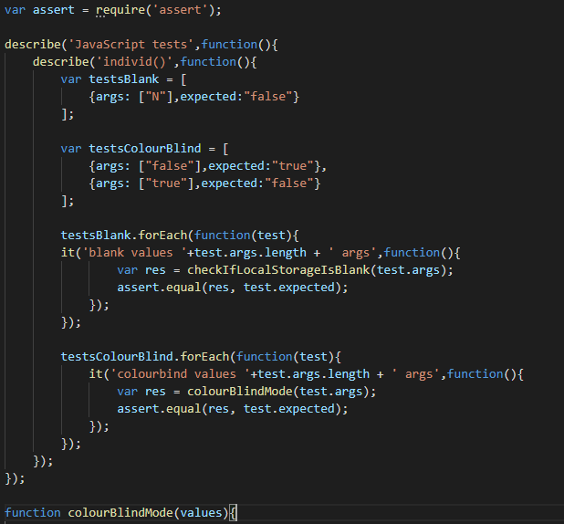

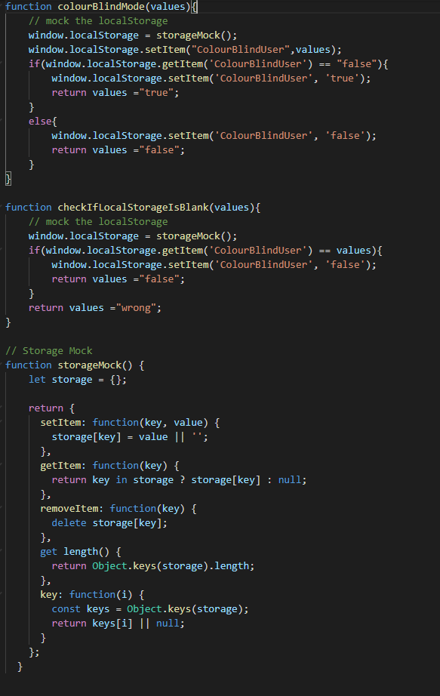

# Mocha test results



